
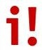

John’s Pre-Sales Engineering Suggested Reading List – Updated May 2026

= Must Read = Part Of Your Library = Informational. Add Later

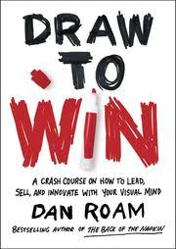 | “Draw To Win”  by Dan Roam | Draw to Win is Dan’s fifth book in the Back Of The Napkin Series – all about the power of visual explanations. My view is that whiteboarding/visual selling is part of any SEs toolkit. This book was written way back in 2016, yet now in the age of AI, being able to sketch and collaborate with your client is a personal differentiator, a relationship builder, and still a way to demonstrate your humanity.  I particularly loved the fact that there was a complete section on sales, an explanation of the seven key quests, and a delightful chapter on the importance of stick figures – a return to humanity. I always found that if you didn’t include people in your visuals, then your picture was very dry and clinical. People use technology. Give it a read. Bring a pencil!
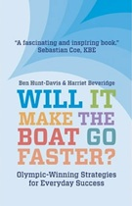 | “Will It Make The Boat Go Faster”  by  Ben Hunt-Davis & Harriet Beveridge | “Go Faster” is a pleasant mix of story, covering the two years leading up to the Olympics, winning a gold medal, lessons learned, and then practical applications to corporate life. In the SE world, going faster can mean increasing win rate, decreasing pipeline dwell time, increasing deal size, and improving SE knowledge and customer satisfaction, etc. It stops you, individually or as an SE leader, from doing meaningless things. That is all in “it depends” territory – but can cover post-sales support cases, marketing events, and generally compensating for the poor behaviour of other departments, notably sales.  If you cannot clearly see how a task/action/meeting will make the boat go faster, then you probably shouldn’t be doing it. You’ll also discover how this philosophy can greatly simplify your life when you apply it to demos and presentations, as you’ll start to remove extraneous material and general feature noise.
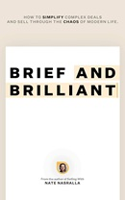 | “Brief And Brilliant”  by Nate Nasrella | This is a book about selling more by saying less, so I’m tempted to stop the review here, but that would not do it justice.  There were at least a dozen occasions when I read a passage and said, “Yes, that’s what we teach – way to go, Nate!!”  One of my standard pieces of advice for the young or even the experienced SE is: “You don’t get paid by the word.” If you combine that with the Executive Connection mantra of “Be Bright, Be Brief, Be Brilliant,” you have a summary of Nate’s book. One of our primary SE roles is indeed to simplify (but not dumb down) the chaos and complexity of technology. It’s still something that separates humans from robots.  Nate takes you through practical exercises and examples of compression, elimination, and (my word) decomplexification. I particularly loved the chapters on inertia and the “Do Nothing Inc.” customer. Just that section about verbalizing the Cost Of Inaction (as opposed to ROI) is worth the price of the book. Buy it. Read It.
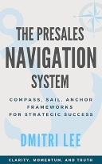 | “The Presales Navigation System”  by Dmitri Lee | The book is really a collection of “this one time, we had a deal…” narratives, each yielding a set of learning points. I loved the fact that the stories struck a balance between wins and losses. (We do indeed learn more from pain than gain when in sales.) Two messages stuck with me after reading. The first is “if you see something, say something.” The second message is to take control. The COMPASS provides direction, SAIL creates momentum, and ANCHOR holds a steady path, all of which play into this.  Structurally, I struggled with the book, especially as it boasts only 5-star reviews on Amazon. First, there are almost no visuals. Secondly, Chapter One begins with “Start With The End”, yet you have to complete 92% of the book to learn about COMPASS, SAIL, and ANCHOR. Finally, and this may be a generational thing, the stories left me breathless, and not in a good way. They read like one of those single-sentence format LinkedIn posts.  Recommended as a supplemental part of the SE Library (but it’s only 99c, so get it anyway!!)
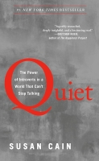 | “Quiet”  by Susan Cain | When we run our informal personality surveys during MTS workshops, we ask SEs to rate themselves on an introvert / extrovert scale of 0-10. 10 being that jolly, steak and red-wine buying, handshaking rep we’ve all worked with at some point. The average SE score is 4.3, and the AEs score 7.9. In fact, the most common feedback is “I’m really a 3 or 4 at home, but I feel I have to +2 that at work.” Susan’s book (and it’s a decade old) was a validation for me. I’m a social introvert, as are many SEs. Shyness is seen as bad, and collaboration and teamwork are the rage – yet that’s not how many of us work. Quiet is packed with insights, ideas, and techniques to function in today’s world – and applied both personally and professionally.  I highly recommend this book for anyone who is a 6 or less, manages introverts, or lives with one at home.
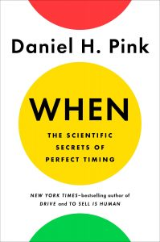 | “When”  by Dan Pink | Timing is everything! Yet so much sales and technical training focuses on the HOW to accomplish a task, rather than the WHEN. Wouldn’t it be nice to know when to ask to go first or last when presenting, the best time to demo to ensure attention, or if you have a legitimate excuse to take an afternoon nap? Dan Pink, in WHEN, spends an intriguing 200+ pages examining the science behind WHEN, rather than the HOW or the infamous WHY. At the end of each chapter, he then presents a “time-hacker's” summary of lessons learnt and how to maximize the time dimension of your life.  I highly recommend this book and am adding it to the essential list for my SE Library.
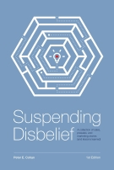 | “Suspending Disbelief”  by Peter Cohan | Peter is famous as the creator of the “Great Demo” franchise and the infamous “Do The Last Thing First” strategy for your demos – often copied but never bettered! This book is a collection of truly awful, amusing, or insightful experiences that have occurred during Peter's long career in sales, presales, and marketing. Each story is a life lesson in the form of a moral (or fable), designed to help you avoid a similar fate. You’ll also pick up some presales history and learn the origins of the Demo Harbour Tour, Zippy Mouse Syndrome, and, of course, Do The Last Thing First.  There are three dozen stories in the book. If just three or four of them make you say “huh, I didn't know that” or even “wow, I still make that mistake..” , you’ll get your money’s worth. My personal favourite is The Tradeshow Story, illustrating the power of language and why US-based Marketing departments are often clueless.
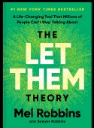 | “Let Them”  by Mel Robbins | For context, this is a mainstream New York Times bestseller, a multi-million-dollar book. I’m going to look at it from a Sales Engineering perspective (as Mel has sold a few more copies of her books than I have of mine), rather than as a standard self-help book.  The central premise of “Let Them” is to realize the boundaries of your control over things, and especially the thoughts and actions of other people. So what happens when you apply “Let Them” and the subsequent “Let Me” in the world of the Sales Engineer? At first glance, it may seem that you turn into a doormat and let everyone push you around, and you lose control. Yet the delineation is understanding what things you (and your SE team) have control over, and where you want to expend your energy and political capital. Suppose support and engineering refuse to prioritize a bug fix, despite your best efforts. Rather than whining about it and complaining for the next two weeks (and you know you do..) you say “Let Them.” Put it away (which is not the same as Let It Go!) and then apply “Let Me” to track the impact of their actions on the sales funnel and customer satisfaction.
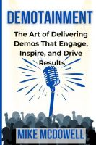 | “DEMOTAINMENT”  by Mike McDowell | Two quotes jump out at you within the first ten minutes, summarizing the book's context. First, “I’ve always believed that structure and creativity don’t have to compete,” and second, “Audiences connect with characters, not scripts.” Instead of the classic chapter structure, the book is laid out in seventeen scenes (as in <all the world's a stage, and all the men and women merely players>). Each scene covers topics such as energy, audience engagement, or visualization questions. A scene starts with the Director's Notes, then moves into practical examples with step-by-step guidelines and phrasing.  Here’s the big scandalous secret – there is nothing new in this book. It’s a well-constructed collection of highlights from Mastering Technical Sales, Command Of The Message, Great Demo, other extant literature, and the few bits of Demo2Win that are still relevant. What is unique is the method Mike uses to make the material engaging and memorable. And for that, he deserves a big round of applause from the audience.  Where does this book fit into the SE lifecycle? Once you understand Business Value (not just Technical) Discovery and have some structure from your preferred form of demo delivery, you can use DEMOTAINMENT to fine-tune your demos into the full Hollywood/Bollywood production.
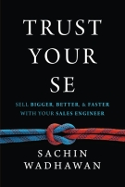 | “Trust Your SE”  by Sachin Wadhawan | The book is eclectic in content, ranging from a basic description of the SE role to the nuances of SEs' interactions with every other part of the organization. It also features a massive collection of interviews from a gallery of SE rockstars like Peter Cohan, Brian Cotter, Nathan Booker, Chris Browne, Devina Yadav Baker, and multiple other industry “villains”. (Disclaimer – I wrote the forward and feature in the text.)  Here’s the book's value. During every MTS workshop, we are always asked, “How can I work better with my salespeople?” It’s a tricky question, as the SE's job is to make the rep successful, not necessarily happy. You’d think there would be a correlation, but that is NOT always the case. This book answers that question, in that you highlight certain key passages, give it to a sales rep to read, and say, “This will help you understand your SE. They’re not like you!”
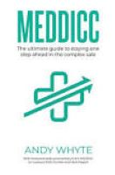 | “MEDDICC”  by Andy Whyte | Andy Whyte walks us through the MEDDICC methodology (and all of its variants) in detail. It's probably too much for the regular SE – although if you read the entire book, you will gain an appreciation for the hard work that your account exec counterparts perform. I’d especially recommend the first half of the Opportunity chapter (which lists the many ways to qualify out of a deal) and the entire Discovery chapter. Andy won me over by stating, “Discovery is not a sales stage. It’s a mindset.” Throw in the Decision Criteria chapter as a bonus, and you’ll have a well-rounded view of the methodology.  The book's downside is that it’s challenging to read. The graphics are appallingly small, and much of the text needs a comprehensive edit. Yet, there is enough goodness here to recommend it as a standard read for the Sales Engineer. It’s a prescription for success.
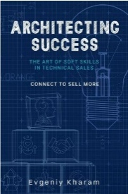 | “Architecting Success (Soft Skills)”  by Evgeniy Kharam | “Soft Skills” (more on that label later) are essential for the #Salesengineer. Soft skills help to bridge the gap between technology and people. Technical Professionals become Trusted Advisors by honing communication and collaboration skills. The #2 skill most desired by customer executives is “Someone who can clearly communicate with me.” The results are in, with supporting data – these are essential skills. Yet, especially over the last 5 years, with the newfound crazy focus on demo skills, they tend to be neglected.  The book's first two parts summarize the topics well, yet part 3 is where the magic happens and makes the book a strong “buy this and read this.” I’d recommend this book for all SEs. Especially as a pre-read before launching into a demo skills or executive conversation workshop.
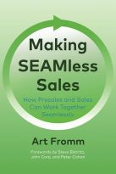 | “Making SEAMless Sales  by Art Fromm | We deliver hundreds of Sales Engineer professional skills workshops every year, and the #1 question we’re asked during breaks and end-of-day is “How can I work better with my sales rep? (And how can I get them to work better with me too?). It’s a global issue, and Art Fromm’s Making SEAMless Sales is the first book which attempts to solve this problem, going beyond the “partner effectively and cooperatively” platitudes you can read elsewhere.  Another reviewer coined the phrase “The Symphony of Sales” to describe the book. Art blends standard sales strategies with Great Demo and Mastering Technical Sales to produce a lightweight selling/buying framework—all geared around teamwork and the SE-AM (Account Manager) relationship.  Pick up a copy – it’s worth the read.
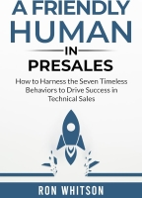 | “A Friendly Human In Presales”  by Ron Whitson | The book is an easy 200-page read, except it really isn’t - because of the wonderful suggestions and exercises that Ron provides at the end of each chapter. The Seven Timeless Behaviours are “Be Authentic, Listen Actively, Show Empathy, Have A Conversation, Practice Humility, Tell A Story, and Leave An Impression. You can initially look at that list and think, “Hey, I do all that!” The truth is that we do not.  After an intro chapter containing the fantastic phrase “Hi, my name is Ron, and I’m a Geek,” the following seven chapters focus on each behavior. They’re all relevant to the SE, yet my favourite was #1-Be Authentic.  I’d recommend this book to any SE at any stage in their career—you’ll definitely learn something from it.
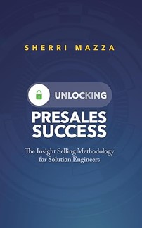 | “Unlocking Presales Success”  by Sherri Mazza | The author has been around the SE ecosystem for a while, with great major account experience from companies like Oracle, VMware, and Sun Microsystems. Her book encapsulates all those experiences and is a fantastic repository of ideas and processes for major and strategic account SEs.  Sherri has taken concepts like “The Art of The Possible,” added some flavoring from The Challenger Sale, and created “Insight Selling.” Although it’s not the revolutionary new sales concept as described in the book, if you are responsible for creating a TAP—Technical Account Plan—this is a fabulous framework to get started.  The first few chapters contain many “you should do this” statements without telling you HOW to “do this.” Then, the book picks up pace and becomes more prescriptive. I’d recommend it for any SE or SE team engaged in Major Account Planning who are struggling with a “sales-oriented” methodology and need something more relevant to the SE..
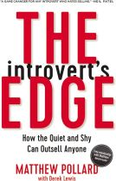 | “The Introvert’s Edge”  by Matthew Pollard | This is one of the most highly rated business books on Amazon, and it also perfectly describes me—especially when I first started as an SE and later started my business. Matthew believes that sales is a skill like any other, which anyone can learn or master – the secret is in leveraging your strengths, not changing who you are. Since most (but certainly not all) SEs are more introverted than their sales counterparts, I expected this to be a great fit for our profession. Not quite! The first third was painfully slow, the middle third, particularly the chapter on storytelling, was great, and then the back third descended into platitudes and ponderous prose. I realized that the constant use of anecdotes and “feel-good” stories, coupled with a lack of specific examples, is what left me feeling irritated and unfulfilled.  Recommended for early in career and Academy SEs or anyone making that transition from technician to SE. Also for any friends and family starting their own small business.
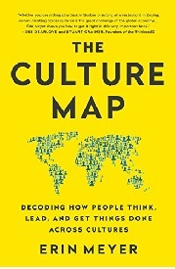 | “The Culture Map”  by Erin Meyer | What happens when Indians have to work with Germans, the Japanese team with Swedes or a US sales team makes a pitch in the Netherlands? Quite often, it’s a veritable mix of cultural issues, misunderstandings, and (hopefully) a few laughs. Very few Sales Engineers work in a totally homogenous cultural environment. Over my career, I’ve had bosses from 4 different countries, not counting Texas, had employees from 11, and I’ve sold close to 30. Wouldn’t it have been nice if I at least had a guide and some wise words of advice that might have stopped me from putting my foot in my mouth multiple times? Erin Meyer’s The Culture Map is that guide.  This is an extremely well-written book, full of both theory and application and linked with highly entertaining stories. It’s a rare book that teaches you and makes you laugh at the same time. If you deal with or work for multi-national organizations, operate in cross-border teams, or are just genuinely puzzled by other cultures, this is the book for you.
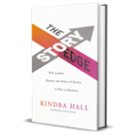 | "The Story Edge"  by Kindra Hall | The #1 theme in this book is that humans are wired for stories – that’s how we have communicated and evolved over the past 400,000 years. That’s the edge that (for better or worse) enabled us to climb to the top of the food chain. Yet we’ve lost that edge in business. We ignore it, forget to use it, or underestimate its utility. We say, “There isn’t enough time for a story,” or “People just want the facts.”  In particular, I liked the three truths of Story Forward Leadership contained within the book. I enjoyed the read. It is, like Stories That Stick, a compact 200 pages full of examples and practical advice. Recommended for all SEs and especially for leaders.
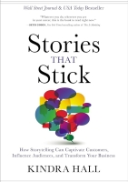 | "Stories That Stick "  by Kindra Hall | One of the prime messages in the book is that technology is essentially lifeless – and it is our job to bring it to life emotionally. That’s way more than reciting facts and figures, speeds and feeds, and then plowing through a boring Product Marketing slide with an image and eight bullet points! It’s even more than Use Cases. Part 1 of the book deals with the power of storytelling, and Part 2 dives into the four essential types of story (good news: to start with, we only need the Value and Customer stories). Part 3 covers the tactical do’s and don’ts.  I enjoyed this book; it is a short and compact 200 book, yet it is full of stories and practical advice. For years, I’ve always had a part of my mind thinking: “I wonder what the story is behind that..?” Now I know how and why that part of my brain gets lit up. Recommended for all SEs. Ignite your customer’s brains too!
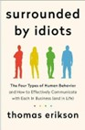 | "Surrounded By Idiots"  by Thomas Erikson | We’ve all had those days when we feel we’re surrounded by idiots who just cannot comprehend what we’re saying. In saner rational moments, we also understand that they’re not actually idiots (with a few exceptions), but they’re people who think and process differently than we do. That’s the premise of Thomas Erikson’s book. The subtitle “How To Effectively Communicate With Each In Business (and Life) " describes the contents better.  As technical salespeople, we deal with this effect every day – working with our sales partners, support, development, our boss, and, of course, our customers. Highly recommended – and if you do like this book, it’s part of a series of “surrounded by” titles from Thomas, which I haven’t yet read but probably will soon.
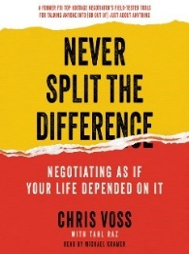 | "Never Split The Difference"  by Chris Voss | As SEs we negotiate every day – with customers, sales reps, our boss, product management, engineering, support and the list goes on. Negotiating is an essential business skill, which Chris Voss approaches from an entirely different angle in Never Split The Difference. Chris is a former hostage negotiator with the FBI who has transferred that hard-earned knowledge into the business world.  You must be prepared for the analogies and context switches between hostage negotiating and business negotiating, although ultimately, you’ll see many structural similarities. For the SE who feels that both their calendar and their reps are out of control, this book offers many takeaways that will help. It's a great read!
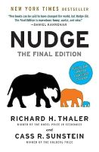 | “Nudge – The Final Edition”  by Richard Thaler & Cass Sunstein | I truly enjoyed reading Nudge, The Final Edition. I found it funny, insightful, well-written, and full of ideas – not just for Sales Engineers. If you think about our profession, extending the analogy, salespeople tend to be aggressive and push and shove, while SEs are kinder and gentler, and we like to nudge our customers, peers, and partners. Nobel Prize winner Richard Thaler and his colleague Cass Sunstein explain the process of becoming a choice architect and how that can subtly influence the behavior of others.  As a bonus, you can use the ideas for improving your personal life around health, wealth, and happiness. Buy this book. You’ll need to do some conversion work to make it relevant to your personal situation, but it’s worth it.
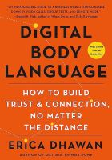 | “Digital Body Language”  by Erica Dhawan | In “Digital Body Language,” celebrated collaboration guru and self-described passionate communications junkie Erica Dhawan takes us through the (not-so-new) world of digital interactions. This book was a major and positive surprise! I’d expected a how-to Zoom/Teams/Meet better book. Instead, Erica takes a much broader view of digital interactions, which includes texting, email, phone, Slack, WhatsApp, etc.  Each chapter presents a different view of the various digital body language types, ultimately broken down by culture, country, generational, and even gender (yes, there are fundamental differences). It’s certainly made me take a hard look at how I can more effectively communicate with “people not like me.” I’d recommend this book as essential and relatively quick reading for anyone, not just for my usual SE audience!
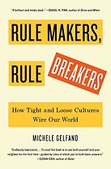 | “Rule Makers Rule Breakers”  by Michele Gelfand | In “Rule Makers, Rule Breakers,” celebrated cultural psychologist Michele Gelfand guides us through the tangle of human culture. She believes that much of how we think and act derives from a key difference in how tightly (or loosely) we stick to cultural norms. Why are clocks in Germany so accurate, whilst they’re frequently wrong in Brazil? Why is the driver of a BMW more likely to run a red light than a Kia? Why is living (and selling) so different in Singapore vs New Zealand or Israel?  I found this to be a really fun and enlightening book, with a number of small “ah-ha” moments hidden inside. It’s really given me a different viewpoint on why certain peoples, countries, states, and classes act the way they do. Reading this in conjunction with Erin Meyer’s “The Culture Map” is eye-opening.
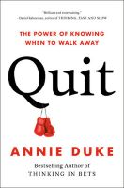 | “Quit”  by Annie Duke | In Quit, World Series Of Poker Champion Annie Duke takes us through the science and psychology of quitting and makes a convincing case that it is a business (and personal) decision skill worth developing. It’s a virtue, not a behaviour maligned and despised by so many. I loved her concept of “kill criteria”, which are preset criteria, or gates, which need to be met in order to proceed on any endeavor. Think about that in sales – it’s a fantastic way to qualify out of a deal. SEs say that over 40% of sales call that they attend are poor. Not bailing out soon enough is one primary reason for that horrifying statistic. Give it a read!!
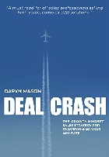 | “Deal Crash”  by Daryn Mason | I’ve always been amazed by tech companies’ reluctance to analyze their wins and losses when asked. Everyone loves successes, and they’re email/slacked around the company. The losses are pushed to the side under the rug. Yet there’s so much to learn from your defeats. Daryn Mason’s Deal Crash guides you through a systematic, blame-free process so you can learn from your mistakes.  I loved this book and recommend it – and I’m not suggesting that everyone needs to create a formal W/L review process, but if it just pushes a few organizations to inspect their losses with a view to improve instead of to blame, that’s a “win”!
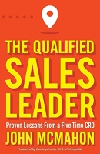 | “The Qualified Sales Leader”  by John McMahon | Every now and again, you read a book that just frustrates you. This is one of those books. It's overly focused on the worst characteristics of an old-school sales rep and how to manage those individuals. So, yes - it does a decent job of reinforcing the basics and foundational skills of qualification and is useful for first-time sales managers.  It misses team-based selling, has a maniacal focus on pain and ignores gain, and the composite characterization of the sales reps and managers is laugh-out-loud. So, if you're totally new to sales leadership and want to learn how it used to be done, it's worth the read. You will learn basic terminology, such as BANT and MEDDIC, and understand how to perform simple pipeline math. It is useful for first-time sales leaders or SEs looking to transition into sales. | 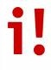
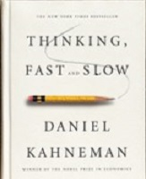 | “Thinking Fast And Slow”  by Daniel Kahneman | Nobel Prize winner Daniel Kahneman takes us on a journey of how thought, emotional reactions, and decision-making are driven by two separate yet interdependent forms of thinking. System 1, the fast system responsible for instinct and intuition, is automatic. You don’t have to do anything to activate System 1; it’s always running in the foreground. System 2, the slow system responsible for self-control and planning, needs mental effort and multiple steps to retrieve and process information. It handles multiplying 14 x 17 (for most of us) or “book a flight to Paris.” System 2 is the mental conscience of System 1, although it usually endorses whatever System 1 decides.  Still looking for a connection to Sales Engineering? Think about how much the instinctive reaction to a demo or a slide drives the rest of a conversation or sales call. It made me realize how important the visuals of a demo, or especially slides, can be in driving a positive System 1 reaction, which then biases System 2. It’s a completely different way of viewing your outbound customer and colleague interactions. Give it a read – your System 2 will thank you.
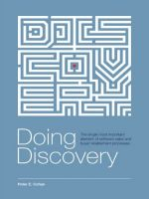 | “Doing Discovery”  by Peter Cohan | The "Dash To Demo" is a curse of the technical sales profession. It's no good giving the best demo or pitching the perfect product presentation if you don't have a clear target. "Doing Discovery" can help you solve that problem. In over 350 pages, Peter Cohan lays out a methodology and a philosophy for the *most* essential part of the sales process. It's about time someone wrote at length about this topic! The book contains theory blended with practical application, tips, techniques, and multiple "what-ifs." You'd be hard-pressed to find a scenario NOT covered in the book.  It's essential reading for every Sales Engineer. That said - arm yourself with sticky notes, highlighters (real or virtual), and a pencil. There are no chapter numbers, no index, and there is a massive amount of text. If you are a visual learner it’s a tough read.
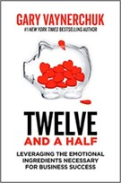 | “Twelve And A Half”  by Gary Vaynerchuk | Traditionally, business leaders have relied on the “hard” skills to make decisions and ignored the softer emotional skills such as empathy and curiosity. In Twelve And A Half, Gary Vaynerchuk explores the 12.5 ingredients/traits that have led to his success.  I must admit that I had very low expectations of this book, yet I thought it was worth the investment for a $9.99 special from a best-selling author. The result was barely. The text is full of platitudes and pushes NFTs incessantly. Its only redeeming feature is many real-life examples that showcase beneficial ingredients like empathy, gratitude, and kindness.
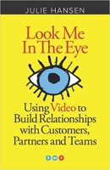 | “Look Me In The Eye”  by Julie Hansen | In early 2020, you needed a Zoom account, a camera, and a bit of privacy – and you were good to go for virtual meetings. Yes, it all still seems remote, tiring, and unemotional. Julie Hansen’s Look Me In The Eye can help you change all that. Even if you think you are a virtual guru, I can absolutely guarantee that you will use highlighter on this book more than any other – it’s that good. Tips range from “if the camera didn’t see it, it didn’t happen” through “how to be a smeaker” (Smile + Speak) to the operational and logistical mechanics of body language and setting.  I took away seventeen (yes—17) action items for ways I can improve my virtual presence. It’s worth reading, and then give a copy to your sales partner as well!
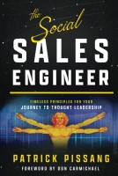 | “The Social Sales Engineer”  by Patrick Pissang | This book is really a love story for Sales Engineers in disguise. We follow the journey of our hero, Elias, as he meets his true love and simultaneously learns to love both his potential and himself. In The Social Sales Engineer, author Patrick Pissang uses an entertaining blend of philosophy, quantum mechanics, and pop psychology; all mixed with tea, to guide us through the development of Elias from a meek, timid and self-doubting SE into a hero of his own making who wins the girl, achieves fame and fortune, and saves the planet.  There is something of Elias in each of us, and that is the book's beauty. It won’t directly help you to give a better demo or improve your PowerPoint pitches. Yet, it will help you in a journey (if you take the first steps) to self-realization and potentially more happiness, innovation, and joy in your SE life. That’s not a bad return for under $20. Give it a read!
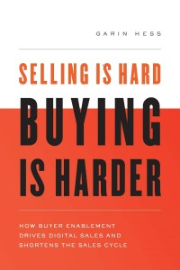 | “Buying Is Hard: Selling Is Harder.”  by Garin Hess | I get deluged by "sales process and selling" books every month. Rarely does one grab my attention in the way Garin's book managed to do. There is some excellent material here about gently guiding the customer through the buying process (you've seen it multiple times before, and they haven't) and a constant reminder that this is a non-linear process. The more you do in parallel, the faster the opportunity moves through the purchasing cycle.  I particularly liked the chapters on Champion Enablement, Emotional ROI, and why giving up is a good thing.  Definitely worth a read for both Sales Engineers and their Sales Partners - and then put it into action.  I did – and it has made a difference to my business. Thanks Garin!
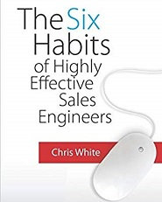 | “ The Six Habits Of Highly Effective Sales Engineers”  by Chris White | Six Habits is a delightful book about the basics and the applied principles of being a Sales Engineer. Chris White breaks the role down into six simple, common-sense, and often-overlooked rules that can help you perform better as an SE. Although the book is a little demo-focused, the line that stayed with me was, “I’ve come to believe that the ability to answer questions effectively may very well be the most important skill we can develop.”  Chris describes his book as being more conversational and less “textbook” than Mastering Technical Sales, which I’d certainly agree with. It supplies a number of fantastic ideas around topics like Discovery, Demos, and Objection Handling, which could really make a difference to both new and super-experienced SEs. The one drawback is that it is extremely platitude-heavy, yet despite that, I’d say go out and buy it.
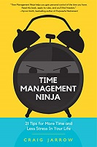 | “ Time Management Ninja”  by Craig Jarrow | I freely admit that I am not the most organized and methodical person in the world (not even in the top 50%!), so I have been a longtime fan of Craig Jarrow (aka Time Management Ninja). Time is the greatest and non-bankable resource of any Sales Engineer. So, becoming more effective and efficient through a better application of time to tasks is an essential component of career progression. 21 Tips should be required reading, and I guarantee that you won’t need all 21 tips, yet focusing on 2-3 of them for the next year seems like a worthwhile investment. I chose #11 One Extra Task A Day – Procrastination and #20 Don’t Create Your Own Friction.  Recommended reading for all but the most organized of us.
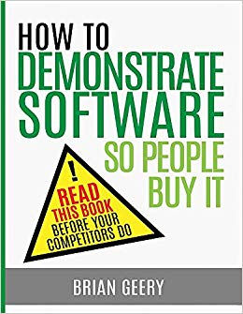 | “How To Demo Software”  by Brian Geery | “How To” is a comprehensive review of the preparation, execution, and follow-up required to deliver the perfect demo. The book, to use Brian’s words, is designed for “the person sitting at the keyboard”. In larger companies that’s the SE. In much smaller companies, that may be the sales rep, who is sometimes the owner/founder/CTO.  I think of this book as a buffet lunch in that there is something for everyone, although you may have to hunt around for your food. If you’re the demo person in your organization, it’s a fantastic starting point for implementing some discipline and process into the demo.
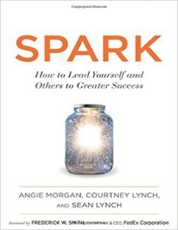 | “Spark”  by Annie Morgan, Courtney Lynch and Sean Lynch | A Spark is all about change. As an SE, the rate of change we see is amazing regarding technology, organization, customers, and almost everything around us. Coping mechanisms like behavioural profiling, improved skills, and good old-fashioned patience can help – but wouldn’t it be nice to cause some change instead of react to it? That’s what Spark is all about, and it focuses as much on preparing yourself for change and then making it happen as it does on leading others.  I liked this book. I was ready to write it off as another “self-help” piece of drivel, but instead, it really challenged me to think about change and being a spark for friends, family, and the thousands of SEs we deal with every year.
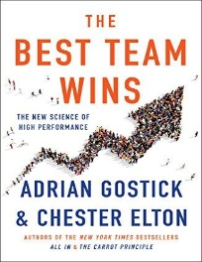 | “The Best Team Wins”  by Adrian Gostick & Chester Elton | In The Best Team Wins, Gostick and Elton yet again (see All In and The Carrot Principle) apply science and research in a practical way to help both managers and individuals figure out the do’s and don’ts of collaboration and teaming. It is NOT a book for managers – it is a book for everyone who works in a team environment. The authors lay out five basic principles, spend quite a bit of time on the “Millennial Challenge” and back their statements up with science. It’s an entertaining and insightful (and relatively easy 200 page) read. Plenty of good stuff in here for the SE community.
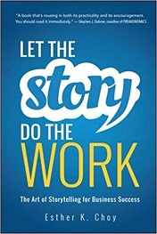 | "Let The Story Do The Work"  by Esther Choy | There are many “Story” books out there, with my all-time favourite being Carmine Gallo’s The Storyteller’s Secret . Esther Choy and Let The Story Do the Work comes a very close second. I liked this book for several reasons – most notably because (unlike many of the ‘jump on the bandwagon” books out there), she focuses on the HOW of using stories in business situation, rather than the WHY. She does a fabulous job of categorizing audiences, providing story templates and giving real life examples that I found instantly relatable. A small section titled “How To Turn 97 Pages Of Data into Compelling Stories” pretty much summarizes the life of the more technical SE.  I highly recommend this book (it’s a $3 purchase here in the US) and am adding it to the essential list for my SE Library.
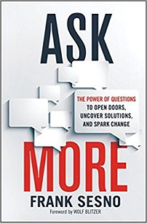 | “Ask More Questions”  by Frank Sesno | Questions help us break down barriers, discover secrets, solve puzzles, and imagine new ways of doing things. But few of us know how to question in a methodical way. Frank Sesno, an emmy-award winning journalist, walks us through the different types and styles of questions – and more importantly, when to use them. For example, I am intrigued by the differentiation between empathic, diagnostic, strategic, confrontational and creative questions. You’ll even pick up tips about varied topics such as hosting a dinner party or handling a confrontational in-your-face job interview.  I really enjoyed this book, although it requires a bit of self-processing; i.e. you really have to think about the material and then how to apply it to both your professional and personal life. For the equivalent of 10 USD this is a great add to the SE Library.
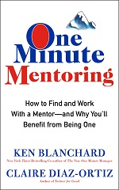 | "One Minute Mentoring"  by Ken Blanchard & Claire Diaz-Ortiz | Is having a mentor really that important? How do you find a mentor? What is in it for both parties? Is there a difference between coaching and mentoring? (Yes: Ask : A Lot : Absolutely in case you are wondering..) At many of our management workshops, we ask how many people have a mentor and how many are actively mentoring someone else. It does not even have to be a formal relationship. The results are rather disappointing – both up and down the chain.  This book is a very short and easy read – written in parable style and tells the story of Josh and Diane. Josh’s career is stalled. He has doubts and questions. Diane is looking out for retirement, and is bored and tired. The story outlines their mentor-mentee relationship and the impact it has on both of them. Definitely a great, yet simple read.
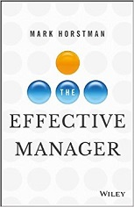 | "The Effective Manager"  by Mark Horstman | Yes, there is a big difference between leading and managing. Over 500,000 books speak to being a great leader. Very few help you manage your team – this is a book that does exactly that. And it’s awesome! This is a casually written, but fact-driven, insight into how to manage a team. It covers the benefits of regular 1-on-1 meetings, feedback, coaching and mentoring – each with dozens of practical stories and examples. Although its primary oriented for a first-line manager, the techniques apply right up the line to VP level.  If you are a first line SE Manager, or hoping for a promotion into that position, this is a must-read. ). I’d also suggest that this might be a subtle holiday present for your boss if you’re looking for more feedback and engagement to help your career development.
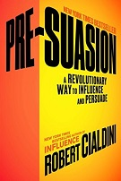 | "Pre-Suasion"  by Robert Cialdini | I loved this book! Thirty years after writing Influence, Robert Cialdini has crafted yet another masterpiece focused on the science and pseudo-science of artful persuasion. The premise of Pre-Suasion is that what happens in the moments before your message sets the scene for the attention and stickiness of that message. Set that in terms of the Sales Engineer and it will make you look at your sales call setup (and particularly demos and presentations) in a completely new light  I’d recommend this book to any SE who has grasped the fundamentals of the role. It’s also a great present for your local sales and marketing folks as they could do a much better job to pave the way for the Sales Engineer to accelerate the sale and the relationship if they put a bit more thought into the process.
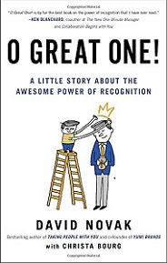 | "Oh Great One!"  by David Novak | David Novak is the cofounder and former CEO of Yum! Brands – think Taco Bell, KFC and Pizza Hut! OGO stands for Oh Great One, the nickname by which David Novak’s grandchildren refer to him. A little recognition goes along way. That’s all you really need to summarize this book. David, a former “CEO Of The Year” shares his 10 guiding principles for employee and personal recognition in a very easy to read story. We follow the adventures of Jeff Johnson as he inherits his father’s failing toy company, and his efforts to turn that company, and the employees, around to restore Happy Face Toy Company to all of its former glory.  If you want to be one of those SE’s who just make everyone around them a little bit better and happier – then this is a great book for you to read. It’s also a pretty good book to accidentally leave on the bosses desk if they need work in this area! Highly recommended.
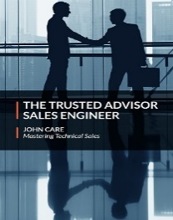 | "The Trusted Advisor Sales Engineer  by John Care | Sales and Pre Sales Engineering leaders across the world have used the Trusted Advisor label hundreds of times over the past fifteen years. Yet it really doesn’t mean that much without a lot of explanation. You may be thinking about some of these questions right now. Becoming a Trusted Advisor is not as simple as it sounds, which is why so many organizations either never try, or make a half-hearted effort. Trusted Advisor – two words, five syllables and fifteen letters hide a massive complexity. For the first time ever, there is now a book specifically designed to start the individual Sales Engineer on the journey to becoming a Trusted Advisor.
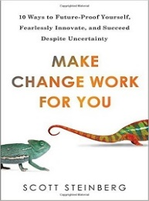 | "Make Change Work For You  by Scott Steinberg | “Change is Constant” may be one of the oldest technology clichés out there – but it is also spectacularly true! Sales Engineers love repeatability and consistency through the sales cycle, yet we also need to continually adapt and change. The market changes, our competitors change and our product changes. Whether you are an old-time grizzled SE veteran or a 6-month newbie, you can’t rest on your laurels and stick to “the way things are” – because you’ll get run over by the changes. Scott Steinberg in “Make Change Work For You” lays out the case for why we need to adapt – and more importantly how do make that change. I’d recommend this book for the general SE population, with the caveat that you’ll need quite a bit of quiet time to read and then process the material.
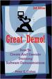 | "Great Demo"  by Peter Cohan | Great Demo! provides sales and presales staff with a method to dramatically increase their success in closing business through substantially improved software demonstrations. It draws upon the experiences of thousands of demonstrations, both delivered and received from vendors and customers. The distinctive “Do the Last Thing First” concept generates a “Wow!” response from customers.
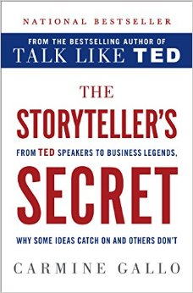 | "The Storyteller's Secret”  By Carmine Gallo | A few weeks ago I was running one of my new hire workshops for a group of graduate SE’s and said “whoever tells the best story inevitably wins the deal”. “No”, they replied, “it’s about who has the best technology and strongest ROI”. The chief legal counsel was up next to review corporate ethics. He started with “He’s right. It’s just like being in court. Whichever lawyer can tell the best and most believable story will win over the jury. It happens all the time!” Smile. It’s not a book, unlike his previous Talk Like TED, that you’ll read cover-to-cover in one sitting, but by picking and choosing from the chapters you will pick up some great ideas in story formulation.  Recommended for SE’s who speak/present/demo regularly and are looking to inject some passion and novelty into their pitches. You’ll have to put some effort and thought into utilizing the key points from the book – but I predict you’ll end up with a more entertaining and memorable customer pitch | 
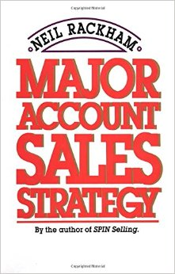 | "Major Account Sales Strategy”  By Neil Rackham | What can you possibly learn from a sales book that was published in 1989? Actually, it turns out that you can learn a great deal, particularly if the author is Neil Rackham – writer of SPIN Selling. Even though Major Account Sales Strategy is over a quarter of a century old, there is an amazing amount of practical (and now time-tested) advice for both the sales executive and presales engineer who deal with large accounts. Recommended for SE’s who deal with large/strategic accounts and may be struggling to assert themselves into the account planning process. It won’t give you the perfect TAP – Technical Account Plan – but it will provide some great ideas and stop you making what are now 25+ year-old mistakes.
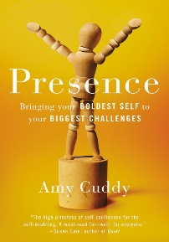 | "Presence”  By Amy Cuddy | Amy Cuddy, the author of Presence, received a lot of positive press a few years ago over her TED talk on Power Poses (it’s definitely worth watching!). Her assertion was that simply by adopting a body pose that was expansive – think hands on hips or SuperGirl – it would improve your confidence and overall body language.  Start at Chapter 6 if you are an SE seeking some guidelines for making more of an impact in meetings and presentations, having people listen to your ideas, and being more assertive with your sales counterparts then this is a worthwhile read. I’d also recommend it for every female Sales Engineer struggling in a male-dominated culture. Highly recommended.
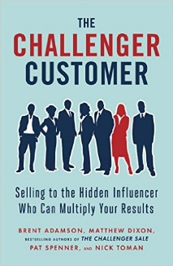 | "The Challenger Customer ”  By Brent Adamson & Matthew Dixon | I’ve long maintained that most sales processes (and therefore QBRs) have an unhealthy fascination with find the all-powerful “coach/mentor” within your accounts. Nowadays it is groups, committees and informal internal customer alliances that buy – usually in a long, drawn-out process. This provides the research and logic that helps dispel the coach-is-everything myth.  They divide customers up into seven different categories, and show the importance of each customer within the category (think Go-Getter, Teacher, Guide, Friend etc..) Their research shows that an average of 5.4 people are formally involved in the decision making process to buy from you – and you need to tailor your message to each of those 5.4 people. Except it’s not that simple …
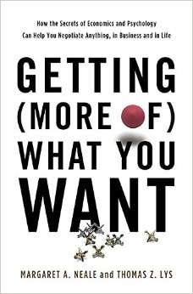 | "Getting (More Of) What You Want”  By Margaret Neal and Thomas Lys | Getting (More Of) What You Want proves that good negotiators are not born – they are made. In the making is good dose of science, common sense and psychology. The book gives you some really interesting insights (along with some practical tips) about the how and why of negotiation. From simple things like use “agreement” instead of “option”, to “don’t settle the easy items first” to the complex and controversial “it usually makes sense to make the first offer”.  I really enjoyed this book (and have immediately put a few ideas to work) and highly recommend it for SE’s – once you have read Getting To YES by Fisher and Ury which is the gold standard for negotiation.
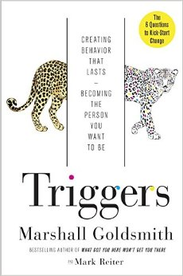 | "Triggers”  By Marshall  Goldmith | I’m a big fan of Marshall Goldsmith, and think his 2008 best-seller “What Got You Here..” is one of the best leadership books ever written. Although Triggers isn’t quite in that category it’s definitely a worthwhile and easy 200 page read. Marshall looks at the psychological and environmental triggers which surround us and prevent us from becoming a “better person” both at work and in our home life. It’s fair to say that every SE wants to improve themselves, and that most SE’s have a plan of some form to accomplish that – however, to quote Mike Tyson “Everyone has a plan until they get punched in the face”.
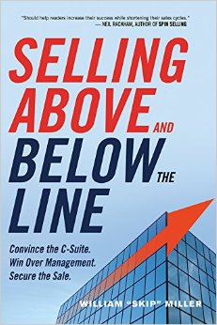 | "Selling Above And Below The Line”  By Skip Miller | Skip Miller’s Selling Above And Below The Line deals with different sales strategies for different buyers. He defines ATL (Above the Line) as the executives and BTL (Below The Line) as the User/Buyers. It’s a broad but strikingly effective form of differentiation. BTL buyers care about the “now” and the features and functions of whatever you are selling. ATL care about numbers – specifically related to time, money and risk – factored by what happened in the past (think Pain) and what could happen in the future (think Gain).
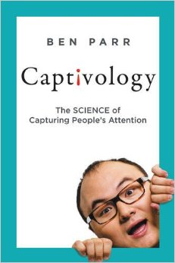 | "Captivology”  By Ben Parr | Today we can’t even go through a business meeting, or a family dinner, without someone pulling out their phone to check email, Facebook or Twitter. Attention has become a precious commodity. It’s become a constant battle to capture your customer’s attention and then to persuade them why you are uniquely qualified to solve their problems or to win their business. Ben Parr’s Captivology takes a look at this battle and provides both the science and specific examples in how to capture and then maintain attention.
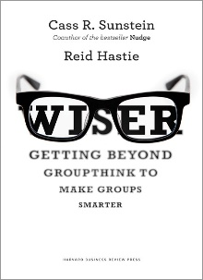 | "Wiser: Getting Beyond Groupthink”  By Cass Sunstein | In about 250 pages learn why groups often don’t reach the correct decision, and then – more importantly – explain how you can fix that. What really appealed to me was that this information is relevant whether you are a driver-driver executive trying to get things done, a subject matter expert who needs to share information, or the most junior person in the room who just happens to disagree with the majority.  If you participate in decision-making meetings (which I think is 99.9% of my readers) I highly recommend this book. BUT – be warned, it is not a light on-the-beach type read. You need peace and quiet for a couple of hours and have to take notes about the great ideas and insights you’ll receive. It also has a “western” bias so would be good reading for Asia-Pacific and Middle Eastern SE’s doing business with (say) US headquarters, but not so much the other way around.
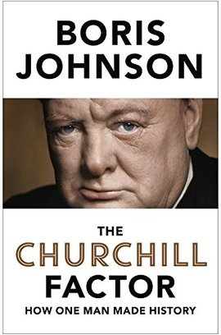 | "The Churchill Factor”  By Boris Johnson | On a different leadership note I just finished a book by Boris Johnson (mayor of London) about The Churchill Factor. For students of leadership, determination and total non-political correctness it is a fabulous read and offers great insights into the man, the country and the two world wars. Highly recommended.
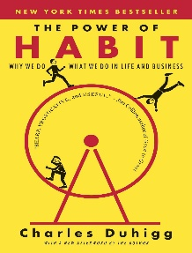 | "The Power Of Habit”  By Charles Duhigg | Charles Duhigg’s The Power of Habit spent 60 weeks on the New York Times best-seller list so I figured there must be some good contained within the book. There is, but you have to work at it is not easy to find. Habits dictate over 40% of our life and really explain why you do what you do. By understanding the cue-routine-reward cycle you have an opportunity to enact change, if you choose.  This book isn’t going to give you a cookie-cutter step-by-step approach to breaking old habits and forming new ones, but .. you’ll understand the psychology behind them and you can adapt that to your circumstances. As an SE there are plenty of bad habits we fall into (interrupting the customer, talking tech before business, feature-driven-demos) that we can shift towards goodness with some effort .. this is a pathway to do that.
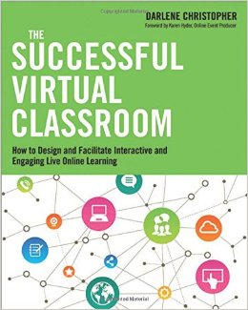 | "The Successful Virtual Classroom”  By Darlene Christopher | Instead of reading sales-oriented books to learn about virtual presentation techniques I decide to review Darlene Christopher’s The Successful Virtual Classroom and look at it from an education viewpoint. There is nothing wrong with borrowing ideas from a similar profession.  The first four chapters are heavy going and fairly basic, and other than the PREP model -- Plan, Rehearse, Execute, Post Review – I didn’t get much out of them. And then I struck gold! The middle chapters on Design, Effective Facilitation and Global Implications were full of tips, techniques and a couple of concepts I hadn’t even considered. They absolutely made the book worth reading.
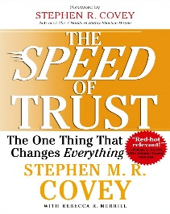 | "The Speed Of Trust”  By Stephen M.R. Covey | One of my favourite discussions with Sales VPs is to ask them what causes friction in the sales cycle and slows their deals down. Two common answers revolve around poor internal processes and customers simply delaying purchase decisions – and both of these have to do with trust – internal and external. Stephen Covey’s The Speed Of Trust (ebook) looks at trust and makes the case that trust is something hard and measurable, rather than soft and intangible.  I highly recommend this book and it’s something that every SE should read. It is a little generic (and that is its strength) so you’ll have to interpret and internalize the behaviors for a SE, but it is worth the effort.
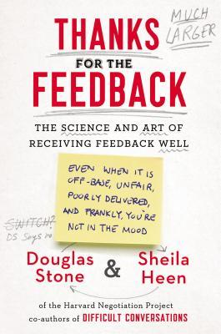 | "Thanks For The Feedback”  By Douglas Stone & Eileen Heen | During my corporate leadership career, I must have attended dozens of HR sponsored classes around the employee feedback and development process. All of them designed to help managers give better feedback to their staff. No question that it is a much-needed skill as a recent survey of ours showed that 82% of SE’s in one large company felt they didn’t get enough feedback from their boss (40% said they received none!)  BUT .. what if we looked at the other half of the feedback loop? How can individuals receive and process feedback better? Wouldn’t that make a difference? That is exactly the approach in Thanks For The Feedback.
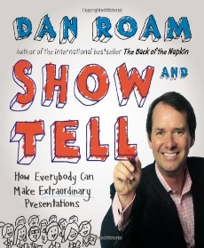 | "Show And Tell”  By Dan Roam | Dan Roam’s Show And Tell is one of a series of follow-on books from his best-selling Back Of Napkin series. If you are a fan of White Boarding and Visual Selling in general then you are going to like this book. Dan looks at the standard four styles of story (he calls them Report, Explain, Pitch and Drama – other people have different names for them) and takes you through a standard thematic outline for each.
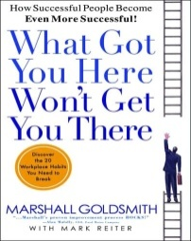 | "What Got You Here…”  By Marshall Goldsmith | Goldsmith, an executive coach to the corporate elite, pinpoints 20 bad habits that stifle already successful careers as well as personal goals like succeeding in marriage or as a parent. For the Sales Engineer there are some vital interpersonal skills you can use which will help you build and improve your career.
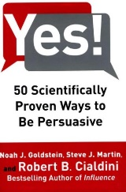 | "Yes! 50 Scientifically Proven Ways To Be Persuasive"  by Robert Cialdini | One skill of the exceptional Sales Engineer is to be quietly and effectively persuasive. Part of that lies in knowledge, competence and confidence. The other part comes from how you structure and deliver your message. Robert Cialdini’s “Yes! 50 Scientifically Proven Ways To Be Persuasive” lifts up the covers and reveals a little more about the theory and the practicality of persuasion. There is much in this book that a Sales Engineer can employ in their everyday job functions.  I really enjoyed reading this book and think it would be a great team book for a manager to assign to their staff to pick a chapter and internalize it for the SE job. Highly Recommended
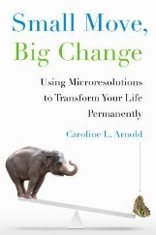 | "Small Move, Big Change"  by Catherine Arnold | This is about the time of year when all your good intentions for the New Year (Western or Chinese) start to fade away. Catherine Arnold’s Small Move, Big Change provides an alternate mechanism for successfully completing your resolutions. Make them smaller and make them specific – and that is a micro-resolution. For example, I may say “I will be more organized”, but what does that mean and how can I judge success? A micro-resolution is more like “I will complete all my expenses and bill my clients within 48 hours of returning from a trip”. The intent is that it is easier to turn these behavioral changes into a habit (it takes about 6-10 weeks) such that you no longer think about them.  I really like this approach as I started back in December and am currently 3/3 in my microresolutions. So if you are looking to make some changes in your personal or professional life during 2014/Year Of The Horse give it a try!
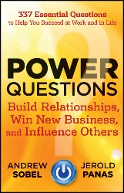 | "Power Questions"  by Andrew Sobel | This is a simple, easy-to-read book that is split into over 30 short and sharp chapters – which cover the basics of the 337 Essential Questions that the authors promise you on their title page. As an SE, it’s a great read – it will teach or remind you that you should never answer a question if you don’t know what the customer is really asking (don’t guess!) and also that you need to focus as much on what the customer feels and thinks as you do on the cold hard facts. Plus it has applicability to your life outside of work.
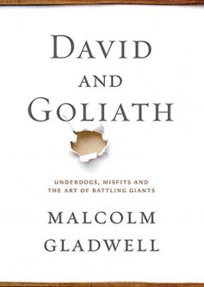 | "David And Goliath"  by Malcolm Gladwell | Malcolm Gladwell’s David and Goliath is very much like his other books – it takes one central idea and beats it to death with a series of anecdotes and selected scientific data. This is a different way to look at setbacks and challenges as they may occur in your personal and professional life. He makes the case that adversity shapes us far more than success ever does. For instance he uses the data around how many prominent people are dyslexic (such as Richard Branson and Charles Schwab) and the impact that disability had on their lives.
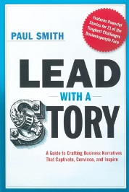 | "Lead With a Story"  by Paul Smith | I’m a big fan of telling stories to make a point, and Paul Smith’s Lead With A Story is right on point. Paul spends a minimal amount of time explaining why stories are good before he dives into a number of practical, real-world examples. Whether you are looking for a story to inspire, to motivate, to help internalize or simply to explain a tough concept, you’ll find something in this book. In particular, I loved the fact that most of the 100+ stories in this book can be borrowed or repurposed and consequentially used by the reader.
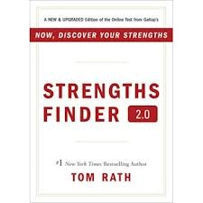 | "StrengthsFinder 2.0"  by Tom Rath | SF2.0 involves an online test which determines your top 5 characteristics or themes. You receive a list of ways to harness and optimize these strengths, and also suggestions to avoid some common pitfalls of the theme. As an SE, it is a fantastic way, for the equivalent of $20USD, to get an alternate view on what you are really good at. Because you need to spend as much time (if not more) in optimizing your strengths instead of papering over your weaknesses. (Or to quote my son: why teach a soccer goalkeeper how to head the ball?).
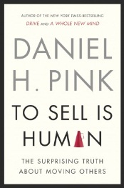 | "To Sell Is Human"  by Dan Pink | One in Nine Americans Work In Sales – But So Do The Other Eight. And it’s much the same in the rest of the world, according to author Dan Pink. People now spend 40% of their time engaged in non-sales selling – that’s persuading, convincing and influencing others in ways that don’t involve a purchase. As an SE, you want the customer to make a purchase, and that’s where the final two sections of this book come in. Dan speaks about attitude, simplicity and clarity of message – all things I believe in. Easy reading and great e-book for your next trip.
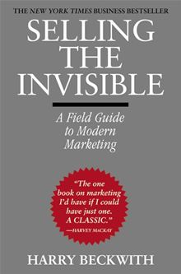 | "Selling The Invisible"  by Harry Beckwith | Harry Beckwith’s “Selling The Invisible” was published in 1997, yet the advice and insights he offered back then are still relevant to 2013. The book deals with selling the intangible – which means people, technology, and the services they provide. My one regret is that I have had this book sitting on my desk for six months – I loved it! I probably went through one entire yellow highlighter pen outlining the key concepts and pithy thoughts contained in the book.
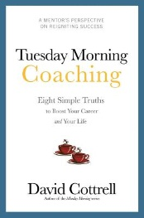 | "Tuesday Morning Coaching"  by David Cottrell | As a Sales Engineer, there are times in your career when you may be questioning yourself and your career choice, or you feel you have been stuck at “senior” for too long and need a change. Often the thing that needs to change is you, and your approach to the job and to the people around you – this may give you the momentum and ideas to do that. An application of From Now On or Consider It Done! may be just what you need.
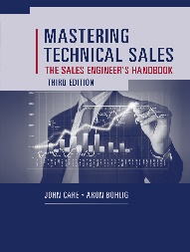 | "Mastering Technical Sales - The Sales Engineers Handbook"  by John Care/Aron Bohlig | The NEW Third Edition! We added 4 new chapters around Business Value Discovery, WhiteBoarding, The Trusted Advisor and Building ROI Cases and we also updated practically every other chapter with revised content reflecting our international and non-software experiences over the past six years. This revised edition offers invaluable insights and tips for every stage of the selling process, explained step-by-step by a pair of technical sales pros with decades of eye-popping, industry-giant success under their belt. It’s really a 350 page job description for you.
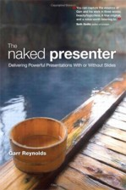 | "The Naked Presenter"  by Garr Reynolds | An interesting blend of Asian beauty and philosophy coupled with practical down-to-earth functional ideas. The subtitle to the book is “Delivering Powerful Presentations With Or Without Slides” – hence the nakedness reference. I was concerned after about 30 pages that Garr was getting too zen-like and philosophical, but then he hits his stride and the remainder of the book is worth its weight in gold. For example - a few of his ideas about how to get increased audience interaction had me muttering “wow, I never thought of doing that!”
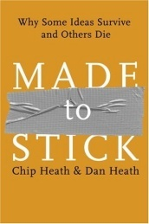 | "Made To Stick"  by Chip and Dan Heath | Ever wondered why some messages “stick” in your brain – and others don’t? The Heath Brothers investigate this phenomenon and map it to a SUCCESS model. Simple, Unexpected, Concrete, credible, Emotional and bracketed with Stories. If that sounds like a recipe for success in presales demos and presentations you are absolutely right. This is a must-read for any SE who wants to stand out from the crowd.
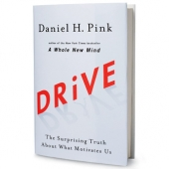 | "Drive!"  by Dan Pink | Carrots and sticks are so last century. What people want now is autonomy, mastery and purpose – as long as they are paid just enough to take the issue of compensation off the table. As an SE (and an SE manager) there is a lot you will recognize in here.
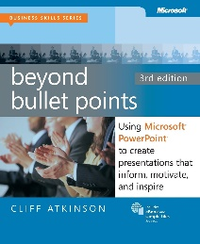 | "Beyond Bullet Points"  by Cliff Atkinson | Cliff shares his innovative three-step method that helps you unlock the amazing story buried in those bullet-riddled slides. He guides you, step by step, as you discover how to combine the tenets of classic storytelling with the power of projected media to create a rich, engaging experience. Learn techniques to help you clarify, visualize, and present your ideas so that your audience will remember your important message.
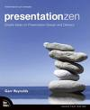 | "Presentation Zen"  by Garr Reynolds | Please don't buy this book! Once people start making better presentations, mine won’t look so good
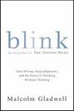 | "Blink" by Malcolm Gladwell | Blink is about the first two seconds of looking--the decisive glance that knows in an instant. Building his case with scenes from a marriage, heart attack triage, speed dating, choking on the golf course, selling cars, and military maneuvers, he persuades readers to think small and focus on the meaning of "thin slices" of behavior.
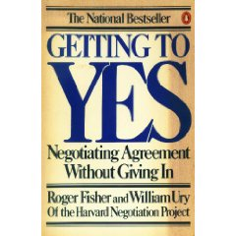 | "Getting To YES"  by Roger Fisher | Why is negotiation important to the SE? Because you negotiate with someone every day – it may be your boss, a customer or more frequently the salesperson you work with. It may be your spouse, parents or children – you get the idea. This book, radically updated from the very first edition over 30 years ago lays bare the principles of negotiation and explains them in simple language with examples (i.e. the “so what?”).
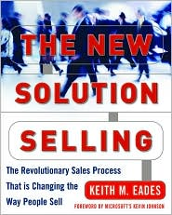 | "The New Solution Selling"  By Keith Eades | Keith Eades provides an update to Bosworth’s classic Solution Selling. After 10+ years the original is starting to show some wear, although it is questionable how much value this revision to the process actually adds.
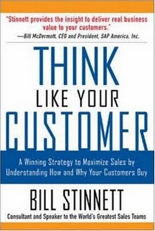 | "Think Like Your Customer”  By Bill Stinnett | A simple down-to-earth explanation of why customers buy results and outcomes and NOT solutions. The first three chapters (70 pages) should be essential reading for everyone. If you are smart you will then finish the book. If you have ever struggled to explain to a rep exactly WHY Discovery is so important consider tis a teaching aid!
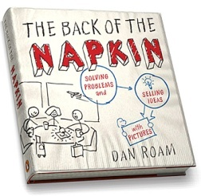 | "The Back Of The Napkin”  By Dan Roam | An absolute favorite of mine. If you are looking for a way to use the Whiteboard more and to lessen your reliance on PowerPoint – this is the essential manual you will need. Dan explains how anyone (no matter how bad your handwriting!) can use the back of the napkin to explain and sell ideas. A must-read.
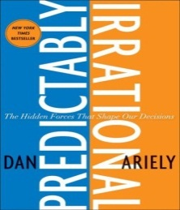 | "Predictably Irrational”  By Dan Ariely | This is a book about economics and psychology – except it isn’t! It’s a book about human nature – about why we turn left when all the facts and logic are screaming “go right!”. Dan Ariel’s Predictably Irrational serves to give us some insight into why people make seemingly unsound decisions and why they behave in the way that they do. Have you ever bought two of a product you would not normally buy so you can get a third one for free?  I really enjoyed this book. Not only did it make me laugh out loud a few times, it also taught me some things about human nature - mine and other peoples!
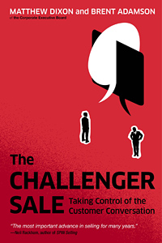 | "The Challenger Sale”  By Dixon & Adamson | Dixon & Adamson’s The Challenger Sale makes the case, based on research by the Corporate Executive Board, that good old-fashioned relationship selling is a losing proposition in the high-tech complex sale. The book posits that the (1) Challenger style reps are much more likely to succeed than any other kind – potentially over-performing by as much as 159%; and (2) Discovery is only half the job. From an SE viewpoint I enjoyed this book, even though it is primarily directed at quota-carrying salespeople. It was an easy read and I am adding it to my Recommended Reading List for Sales Engineers. Thanks to reader Jon Aumann for the suggestion.
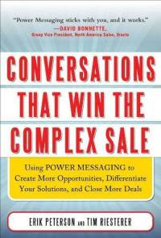 | "Conversations That Win The Complex Sale”  By Peterson & Riesterer | Focuses on just one thing: differentiating yourself from the competition. It is a collection of tips and techniques, which allow you to develop “power positions”, to sell customers on their own story rather than yours and to grab customer attention while you do all this.  I found this book easy to read, although it felt like a 275 page book that should have been 200 pages in length. I’m already predisposed to recommending it as it fully supports the concepts I teach in Mastering Technical Sales – you just get there via a different route. Be warned though – you’re going to have to apply some effort to convert what you read into what you say/demo/present; but it’s worth that effort.
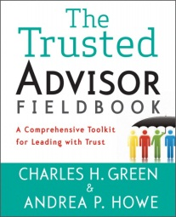 | "The Trusted Advisor Fieldbook”  By Green and Howe | Back as an IT Executive, twenty years ago, every vendor I met with wanted to be my strategic partner. Each of the larger vendors proposed to leave me with a “Trusted Advisor” (TA) to help me make decisions within my complex environment. The TA concept is still in heavy use – yet whenever I ask a group of Sales Engineers and their leaders to define what a TA really is and what that person does – I get all kinds of random answers. In the Trusted Advisor and the Trusted Advisor Fieldbook, Charles Green and Andrea Howe clearly lay out what the role means, how it should operate, and how you develop both the Trust and Advice portions of the role.
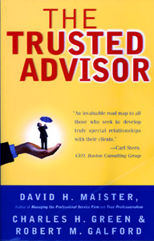 | "The Trusted Advisor”  By Maister, Green and Galford | Although targeted more towards the sale of soft professional services, there is so much that is applicable to selling technology software/hardware. I discovered this book is required reading by the two or three large companies that have a T/A program in-house. To put it all into context, a recent IDC report said that when an incumbent vendor was replaced by a new vendor, that decision was driven more than half the time by the reliability and credibility of the technical s sales team. If nothing else, pay the money to buy the book and read Chapter 15 – What’s So Hard About This and Chapter 22 – The Quick Impact List To Build Trust.
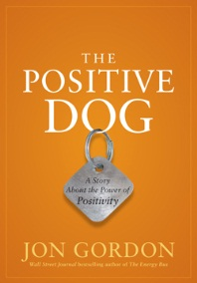 | "The Positive Dog"  By Jon Gordon | Takes a long hard look at how successful salespeople sell both new and existing products into a brand new marketplace. Based on the analysis of over 100 high-tech start-up companies, it compares the sales strategies between the successful and the failing companies. From an SE viewpoint, you get a look into the brain of a highly successful salesperson, his experiences and how he thinks when selling innovative and disruptive products. Chapters 3 & 4 dealing with differentiation and vision are the diamonds in the rough.
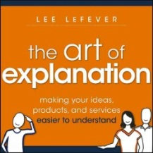 | "The Art Of Explanation"  by Lee Lefever | The greatest obstacle that many people face in adopting a new technology or service -- even if it's free -- is a lack of clear communication. As a Sales Engineer, how many times have you presented or demoed to an audience, and discovered that they just plain do not “get it”? Lee Lefever’s The Art of Explanation takes you through a simple, obvious, and mostly overlooked methodology to plan, package and then present a compelling explanation – of anything.
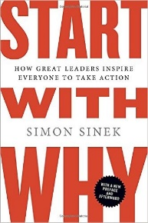 | "Start With WHY”  By Simon Sinek | Although WHY isn’t always a great question to ask a customer (it’s a bit judgmental and confrontational), it is a great question to answer in the minds of your customer. The executive summary for Sales Engineers is that we deal with WHAT, HOW and WHY. Actually we cover WHAT and How pretty well – it’s the WHY that is missing. Despite my misgivings about being a single-issue book, it’s a valuable book and can help in that technical to business transition so many companies are making. Worth the read – and watch the TED video.
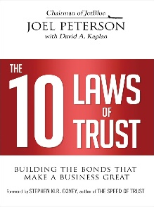 | "10 Laws Of Trust”  By Carmine Gallo | Joel Peterson, the CEO of airline JetBlue, is the latest corporate executive to venture into the field of business books. His “10 Laws Of Trust” is a view from the top of an organization about how leaders can ensure that trust is an embedded value within a company. His 10 Laws are more like guidelines or statements, yet they resonated pretty well with me. On first read, I thought, “this is a leadership book, written by a leader for another leader”. Yet during the second read through (it is a short 100 page book once you remove the indexes and previews) I realized that there is a lot in here for the individual contributor and first line manager. After all – we are all responsible for the brand of “Me Inc.” I thought the best piece of the book was a chart (p14 in my version) about the various types of trust in different organizational hierarchies – from prison to families.
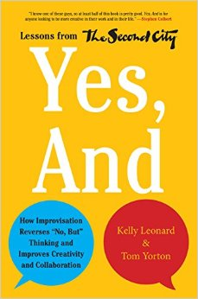 | "Yes, And ..”  By Kelly Leonard & Tom Yorton | “Yes, And ..” is an interesting look into how the skills of improvisation can be effective in a business setting. Written by two of the principals of Second City, Chicago’s famous improve theatre and birthplace of the careers of notables such as John Belushi, Stephen Colbert, and Tina Fey. Improv, or “thinking on your feet”, is an important skill for any SE. It promotes teamwork as you learn to build and support your colleagues and it promotes adaptability and calmness under pressure when things go wrong or when you are put on the spot.
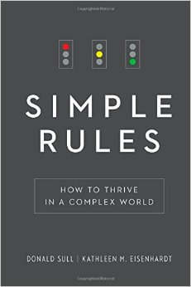 | "Simple Rules”  By Donald Sull and Kathy Eisenhardt | Whilst the world is complex, simple rules can describe the world in an actionable and valuable way. Whilst the world of the Sales Engineer is also complex, some simple rules can aid both personal and organizational effectiveness and efficiency. If only someone could figure out what the rules actually are!  For a book that preaches simple rules, it is not the easiest book to read. However – if you stick with it – you’ll get some valuable insights into how to simplify some complex problem sets and tasks
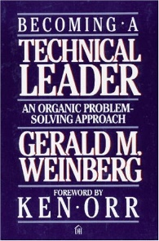 | "Becoming A Technical Leader”  Gerry Weinberg | The heart of the book is the “MOI” philosophy, which is not all about you, but about your staff. The acronym is Motivation, Organization and Ideas/Innovation. Gerry maintains these are the three main drivers of managing techies to create something special in a team that build and creates ideas and solves problems. Motivation is the push or pull to keep people engaged and moving forward; Organization is the structure that helps ideas come into being, and Innovation priming the seeds of the ideas. This certainly isn’t the first book I would recommend for the current or aspiring SE leader (I’d say look at John Maxwell and Marshall Goldsmith). However it’s certainly an interesting and quick read, especially if you are managing a team of super-techies and need some motivational insights in how to relate pinball skills to leadership.
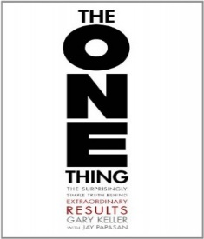 | "The ONE THING”  By Gary Keller | ONE THING focuses on one big question, which is “What is the one thing I can do such that by doing it everything else will be easier or unnecessary?” As an SE we tend to have constantly shifting priorities, but if you are in a situation where you are looking at your task list, with multiple demos, presentations, RFPs, customer calls and eps demanding something by yesterday – it’s really not a bad question to ask yourself. Quite often you can find the lead domino (task), and by knocking that down, others fall as well.  I wished the book spent more time on the process for figuring out what the ONE THING really is, instead of telling you what to do once you find it – but otherwise it was a good, quick read and worth the $12 it cost me. Recommended if you operate under time pressure and aren’t looking for a new system, but maybe just a clarifying approach to time management.
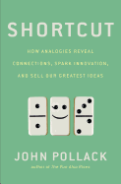 | "Shortcut”  By John Pollack | This book was like a breath of fresh air and helped me cut through my preconceived ideas about analogies like a hot knife through butter. OK – so maybe that’s overdoing it a little, but as a student of language I enjoyed this book. Shortcut is written by John Pollack, former speechwriter to US President Bill Clinton, and deals with how analogies can be used to inform, persuade and ultimately sell our ideas.  Pollack makes the case that for an analogy to function correctly it needs to comply with five rules – (1) Use the familiar to explain something less familiar; (2) Highlight similarities and obscure difficulties; (3) Identify useful abstractions; (4) Tell a story and (5) Resonate emotionally. These really ring true when thinking about how we, as Sales Engineers, have to explain new or different technology to people who either don’t understand t or have never seen it before
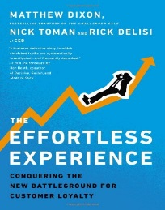 | "The Effortless Experience"  by Matt Dixon et al | Matthew Dixon, co-author of The Challenger Sale, is back in the headlines again with the thought-provoking The Effortless Experience (eBook link). The executive summary is that companies should STOP trying to delight their customers with amazing Customer Service – all they need to do is to make the experience easy and effortless.  Good Read for the SE who not only wants to generate repeat business but also wants to understand the science behind it.
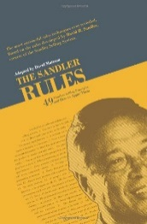 | "The Sandler Rules"  by David Sandler and David Mattson | Good read for the Senior SE or the more Business/Sales oriented SE. Although the book is clearly written for salespeople there is enough in here to keep an SE interested, particularly if you skip the rules about prospecting, pricing and funnel management. The rules about asking questions, listening, not pitching your solution and early qualification are gems. (it’s a very Western, testosterone type of sales process – like Mahan Khalsa’s Let’s Get Real – so needs to be adapted for other parts of the world.
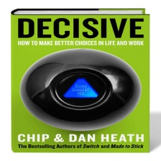 | "Decisive"  by Chip and Dan Heath | In a recent interview about Decisive, The Heath Brothers said “Being decisive isn’t about making the perfect decision every time. That isn’t possible. Rather, it’s about being confident that we’ve considered the right things, that we’ve used a smart process.” As an SE we make decisions every day .. wouldn’t it be nice if we could increase our success rate even by a few percent?
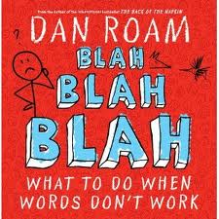 | "Blah Blah Blah"  by Dan Roam | Dan Roam’s Blah Blah Blah is a follow-up to his wildly successful book The Back Of The Napkin. Blah Blah Blah stands for complexity, misunderstanding and boredom – three attributes which seem to be running rampant through our customers brains when faced with PowerPoint, Product Demos and White Papers.  Dan takes you on a journey which shows how and why a picture can be worth a thousand words – but only (my addition) if those words were worth saying in the first place. The book provides more structure to creating and crafting diagrams to explain and solve problems in effect it’s whiteboard grammar.
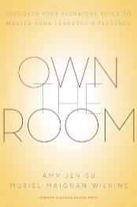 | "Own The Room: Develop Your Signature Voice"  by Amy Su and Muriel Wilkins | Be Brave. Plough through the first 30-40 pages of bland rehashed psycho-pop and you’ll actually get to some practical concepts that apply to the SE job. It’s really all about self-awareness and striking a balance between serving ourselves and serving others. The authors point out that it is a learned trait and opposed to a natural talent – and anyone, with some work, effort and coaching , can develop their Signature Voice.
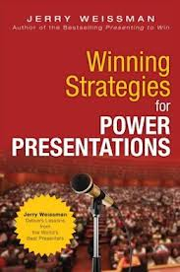 | "Winning Strategies For Power Presentations"  by Jerry Weissman | Jerry Weissman’s Winning Strategies for Power Presentations provides 75 short chapters of advice – each focused on a particular topic. These topics cover diverse areas ranging from simple preparation to voice control and projection, (mis-)using PowerPoint, handling questions and speaking in front of thousands of people. On the basis that everyone can always improve their presentation skills there is enough in this book to guarantee a return on the $15USD eBook price.
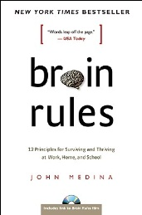 | "Brain Rules"  by John Medina | John Medina’s Brain Rules is a collection of a dozen rules, as seen by a molecular biologist, which illustrate how the brain does (and sometimes does not) work. It’s hard science communicated in a relevant and humorous manner. As a presales engineer you can apply these rules to sales presentations in a positive and potentially quota-changing way
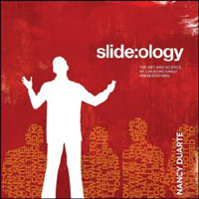 | "Slide:ology"  by Nancy Duarte | One of the best PowerPoint deck designers in the business shares her methodology. Can be a little overpowering if you are a standard screenshot and bullet-point type of person. Good source of ideas for turbo-charging your ideas in a presentation. Maybe a little too much emphasis on why you do something as opposed to how.
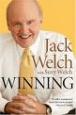 | "Winning" by Jack Welch | As the legendary retired CEO of General Electric, Welch has won many friends and admirers in high places. In this latest book, he strives to show why. Winning describes the management wisdom that Welch built up through four and a half decades of work at GE, as he transformed the industrial giant from a sleepy "Old Economy" company with a market capitalization of $4 billion to a dynamic new one worth nearly half a trillion dollars.
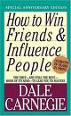 | "How To Win Friends and Influence People" by Dale Carnegie | This grandfather of all people-skills books was first published in 1937. It was an overnight hit, eventually selling 15 million copies. How to Win Friends and Influence People is just as useful today as it was when it was first published, because Dale Carnegie had an understanding of human nature that will never be outdated.
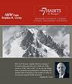 | "The 7 Habits For Managers"  by Stephen Covey | The proven principles of the 7 Habits are applied to leadership roles as Covey teaches managers and other leaders how to define their contributions, develop greater influence, leverage hidden resources, give constructive feedback, and unleash the full potential of their team against critical priorities.
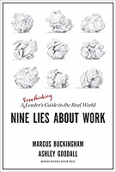 | “Nine Lies About Work”  by Marcus Buckingham & Ashley Goodall | I felt this book should be called “Nine lies about work, except they aren’t all lies .. some are more broad statements which if you take out of context might be lies.” I like Marcus Buckingham and he has a fine pedigree of awesome books which are a blend of science, research and logic. Nine Lies, co-written by Ashley Goodall from Cisco sometimes missed the mark.  This is still worth the read if you’re an SE leader, or potential leader, but approach with skepticism and challenge the assumptions they lay out at the start of each “lie”.
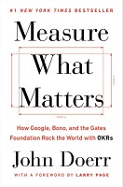 | “Measure What Matters”  by John Doerr | Sadly I really feel John Doerr missed the mark with Measure What Matters. The book is 250 pages of hi tech history and stories rather than a book specifically about metrics. The stories are fabulous, yet if you want to learn about how to specifically research, set, monitor/measure and execute on metrics (or OKR – Objectives and Key Results) you will be disappointed. The insightful “do this” section is shoved into 25 pages of bullet-pointed appendices.  If you are interested in hi tech history or are willing to synthesize what worked for Google, Gates Foundation, Intel and others with your personal experience then read this book, otherwise give it a pass.
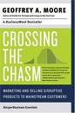 | "Crossing The Chasm"  by Geoffrey Moore | Geoffrey Moore makes the case that high-tech products require marketing strategies that differ from those in other industries. His chasm theory describes how high-tech products initially sell well, mainly to a technically literate customer base, but then hit a lull as marketing professionals try to cross the chasm to mainstream buyers. This pattern, says Moore, is unique to the high-tech industry.
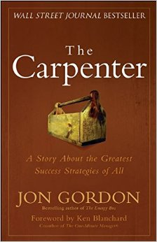 | "The Carpenter”  By Jon Gordon | I’m a big fan of Jon Gordon - and had many positive things to say about The Positive Dog I was hoping The Carpenter would carry on that tradition and nail it with another great story, but this one failed to cut it. This is the story of Michael, an entrepreneur with a struggling business who wakes up in hospital having been saved by a carpenter. Michael starts up a friendship with this master craftsman J. Emmanuel. The tale hammers away at the concepts of positivity, affirmation and doing things because of love and passion versus acting out of fear.  Be warned that it has deep Christian overtones with a Carpenter and a main character called Emmanuel who spends his life helping others. The interesting part is how Michael and his wife Sarah embrace this philosophy and turn their business and their life around for the better. If you like learn through a story books then it’s a good read –. However, if you are new to Jon Gordon I’d recommend starting with The Positive Dog and moving on from there.
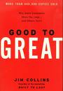 | "Good To Great"  by Jim Collins | Jim Collins asked the question, "Can a good company become a great company and if so, how?" He explores the way good organizations can be turned into ones that produce great, sustained results
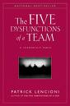 | "The Five Dysfunctions of a Team"  by Patrick Lencioni | Details on Lencioni's "five dysfunctions" (absence of trust, fear of conflict, lack of commitment, avoidance of accountability, and inattention to results), along with a questionnaire for readers to use in evaluating their own teams and specifics to help them understand and overcome these common shortcomings
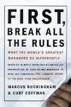 | "First Break All The Rules"  by Marcus Buckingham | In seven chapters, the two consultants for the Gallup Organization debunk some dearly held notions about management, such as "treat people as you like to be treated"; "people are capable of almost anything"; and "a manager's role is diminishing in today's economy."
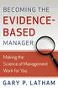 | "The Evidence Based Manager”  By Gary Latham | Leading people is a lot harder than it looks or seems. Effective management is often describes as part art and part science. Most management books focus on the art, with very little reference towards the science of leadership. In about 150 pages, Gary looks at the scientific evidence behind how we can identify and hire high-performing employees, inspire employees to effectively execute strategy, develop and train employees, motivate employees towards high performance, instill resiliency when faced with setbacks and coaching for performance.
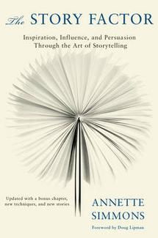 | "The Story Factor”  By Annette Simmons | Guides us through the tactics and techniques around what she considers the six basic story lines you need to influence others. This book is not for the complete novice who wants to learn how to structure and tell stories with little subject experience. It is a worthwhile read for those SE’s who want to raise their story-telling abilities up a level and need some help getting there. Annette provides plenty of easy-to-relate-to examples and her book, just like a great story, has a well-structured beginning, middle and end
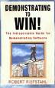 | "Demo To Win"  by Rob Riefstahl | Riefstahl 's book is all about doing demos; what works and what doesn't for doing software demos in front of prospects. You won't find a lot about the overall sales process found in so many other books, just giving good demos and closely related information. There is as much focus on things NOT to do during a demo as there is on things you should do which gets irritating after a while.
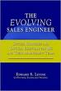 | "The Evolving Sales Engineer"  by Ed Levine | Written to provide SEs with proven behaviors, techniques, skills and mindsets that will enable them to excel given these emerging expectations. Generally a little dry and abstract.
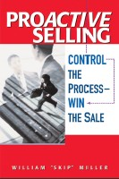 | "Proactive Selling"  by Skip Miller | Skip Miller’s Proactive Selling was recommended to me by a senior SE leader as a set of tools that could layer on top of any sales process that an organization chooses. I reluctantly picked up a copy to read on a long plane flight as I expected the book to be fully of chintzy sales advice and stories. Not so – I was pleasantly surprised. Now there is a lot in this book that will fly right over the heads, and rightfully so, of 95% of the SE’s out there. Yet there is enough to make the $12 purchase price worthwhile.
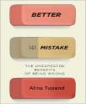 | "Better By Mistake"  by Alina Turgend | The basic premise is that mistakes are healthy as long as they are not fatal and are both made and recognized quickly – subject to the prevailing social or corporate culture. Since we have probably all worked for a company or boss whose attitude is that mistakes are unacceptable that last rider is the key. Unfortunately, the author then beats you over the head (repeatedly) with research and anecdotal evidence to prove her point – to the point that the book is a one-trick pony.
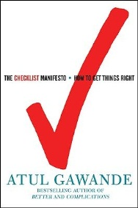 | "The Checklist Manifesto"  by Atul Gawande | Checklists are essential for any Sales Engineer team – installs, POCs, demo prep and webcast prep are just some examples. In a business environment where complexity is increasing and available time is decreasing the opportunity for errors is rampant. Dr. Gawande provides some handy guidelines for making any checklist simple, to-the-point and a single page.
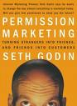 | "Permission Marketing"  by Seth Godin | Godin argues that businesses can no longer rely solely on traditional forms of "interruption advertising" in magazines, mailings, or radio and television commercials. He writes that today consumers are bombarded by marketing messages almost everywhere they go. If you want to grab someone's attention, you first need to get his or her permission.
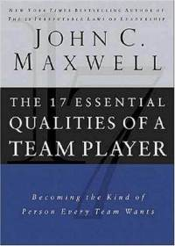 | "17 Essential Qualities Of A Team Player"  by John Maxwell | Maxwell takes you through 17 essential qualities of a team player – ranging from Adaptable to Tenacious. An incredibly useful book both for the leader looking to build/develop a team and for the individual looking for insight into what a “team player” really means.
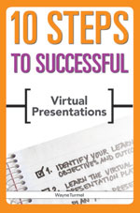 | "10 Steps To Successful Virtual Presentations"  by Wayne Turmel | Sixty percent (that is 60%) of people who sit through online software demos report that they were very unsatisfied with the experience. Two major reasons are a focus on features and boring speakers! Wayne Turmel’s 10 Steps To Successful Virtual Presentations can help you fix that. The book, based on Wayne’s greatwebmeetings.com site, isn’t solely designed for sales pitches, but there is enough good content in there to make it worthwhile reading through each chapter to extract the golden sales nuggets it contains.
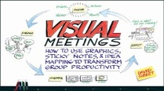 | "Visual Meetings"  by David Sibbet | There is a lot of content in this book. The first 90 pages / 7 chapters provide many tips and techniques for any SE looking to encourage customer participation and interaction in any sales call. I really liked the concepts of pictographs and extending standard icons for Venn diagrams, quadrant charts and mandalas. These are all wonderful “I see what you mean” ideas. The final 150 pages deal with more advanced situations and may be more applicable to professional services/consulting or product management/marketing positions. I’d rate this book as a “read” once you’ve completed and experimented with Dan Roam’s Back Of The Napkin.
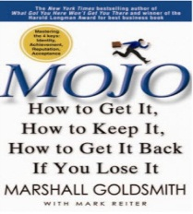 | "Mojo!”  By Marshall Goldsmith | Goldsmith, an executive coach to the corporate elite, defines Mojo as a form of positive spirit within you, how you can get Mojo, improve your Mojo, measure it and keep it. This book didn’t light me up as much as some of Marshalls other publications. If you’re having a crisis of confidence or career then it’s worth a read, otherwise look at some of the other books in this list first.
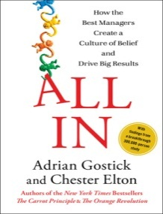 | "All-In"  By Gostick & Elton | Originally, I thought this was just yet ANOTHER motivational book for Managers. Like most of its peers it beats you ever the head with a single idea. In this case it’s E+E+E = Engage, Enable and Energize. However – what I came to realize is that this book speaks not only to managers/leaders but also the employees. It’s as much about self-empowerment as it is engagement. Why is this important to a SE team? Because you can create your own micro-culture, your own beliefs that are independent, yet aligned, with the sales force and the company. Just apply some effort!
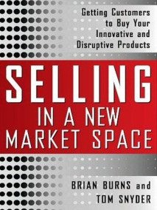 | "Selling In A New Market Space"  By Brian Burns | Takes a long hard look at how successful salespeople sell both new and existing products into a brand new marketplace. Based on the analysis of over 100 high-tech start-up companies, it compares the sales strategies between the successful and the failing companies. From an SE viewpoint, you get a look into the brain of a highly successful salesperson, his experiences and how he thinks when selling innovative and disruptive products. Chapters 3 & 4 dealing with differentiation and vision are the diamonds in the rough.
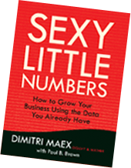 | "Sexy Little Numbers"  by Dimitri Maex | Collecting Big Data is a wonderful thing – and once you’ve stored and processed and backed it up – what do you do with it? Dimitri Maex’s Sexy Little Numbers takes you through the process of using your business data to grow your business. As a Managing Director of Ogilvy One, a premiere advertising agency, Dimitri presents a methodology (in conversational / Socratic format) to get maximum value from Big Data.  If you’re an SE engaged in Big Data, Business Intelligence, Analytics, In-Memory Database or CRM and want to learn more - this is a great book for practical advice and applications.
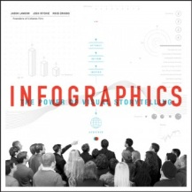 | "Infographics"  Column Five Inc. | This is definitely a book and a concept that you have to invest some time in – both for reading and experimenting. The investment can pay off with some novel presentation memes for both PowerPoint and the WhiteBoard. If you’re a visual thinker or deal with visual thinkers I’d give this book a Highly Recommended, otherwise you may wish to skip it. (I also found it much easier to digest on paper than as an ebook).
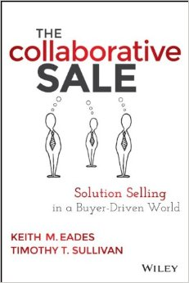 | "The Collaborative Sale”  By Keith Eades & Tim Sullivan | Classic “Solution Selling” has come under fire and criticism since the publication of The Challenger Sale and the July 2012 HBR article “The End Of Solution Sales”. The Collaborative Sale by Eades and Sullivan is basically a 210 page defense of Solution Selling. Updated and modernized, it pushes the concept of collaborating with your customer to create the correct “solution”. You do this, as a seller, by adopting one of 3 personas – the Micro Marketer, the Visualizer and the Value Driver.  As an SE I don’t feel there is much to gain from this book versus good old The New Solution Selling (which I do recommend) unless your company is actually adopting this process. There are changes in promoting customer alignment rather than control and the sections on technology you can use to create a self-brand are interesting, but that’s about it. This isn’t a book for the SE library.

